GUIDANCE
Dun and Bradstreet Universal Numbering System (DUNS) and
System for Award Management (SAM)
All applicants (unless the applicant is exempt from those requirements under 2 CFR 25.110(b) or (c) or have an exception approved by the Grant awarding agency under 2 CFR 25.110(d)) are required to:
- Provide a valid DUNS number in its application. To obtain a DUNS number, please follow the link https://fedgov.dnb.com/webform/
- Be registered in SAM at the time of the award. SAM is the primary registrant database for the U.S. Grant Government. SAM collects, validates, stores and disseminates data about the Grant government's trading partners in support of the contract award, grants and the electronic payment processes. To register please access https://sam.gov/content/entity-registration
Here you can find a comprehensive guide for SAM registration: https://tr.usembassy.gov/wp-content/uploads/sites/91/Entity-Registration-Walkthrough.pdf
- Maintain an active SAM registration with current information at all times during which it has an active Grant award or an application or plan under consideration by a Grant awarding agency.
Organizations are encouraged to register during the application period. Registration is free. The DUNS number can be obtained in up to two business days and registration in SAM can be activated in up to two weeks. If the organization encounter difficulties while registering in SAM, finalist grantees will be assisted by MCI Grants Team to register prior to award.
The information below guides you through the registration process.
- Dun and Bradstreet Universal Numbering System (DUNS)

A DUNS number is a unique nine-character number used to identify your organization. The US federal government uses the DUNS number to track how federal money is allocated. Before registering for a DUNS number check if your organization has already been assigned a DUNS number (if you have previously received US funding, you may already have a number). To verify, enter your organization's data by accessing the following link https://fedgov.dnb.com/webform/pages/CCRSearch.jsp
To register for a DUNS number, access the link https://fedgov.dnb.com/webform/ and follow the instructions. You will need all of the information listed below to obtain a DUNS number:
- Name of organization
- Organization address
- Name of the chief executive officer (CEO) or organization owner
- Legal structure of the organization (e.g., corporation, partnership, proprietorship)
- Year the organization started
- Primary type of business
- Total number of employees (full and part-time)
Allow up to two business days to obtain a DUNS number.

- Register in SAM.gov as a New Entity
- Navigate to SAM.gov.
- Select the “Sign In” button in the upper right corner. Select “Accept” to accept the US Government System terms.
- After selecting “Accept,” the system will direct you to login.gov.
  - Enter your login.gov credentials and select “Sign In.” You may be prompted to enter a one-time security code. (You will receive this code via the authentication method you selected during account creation.) Note: If you do not already have a login.gov account, please create an account.
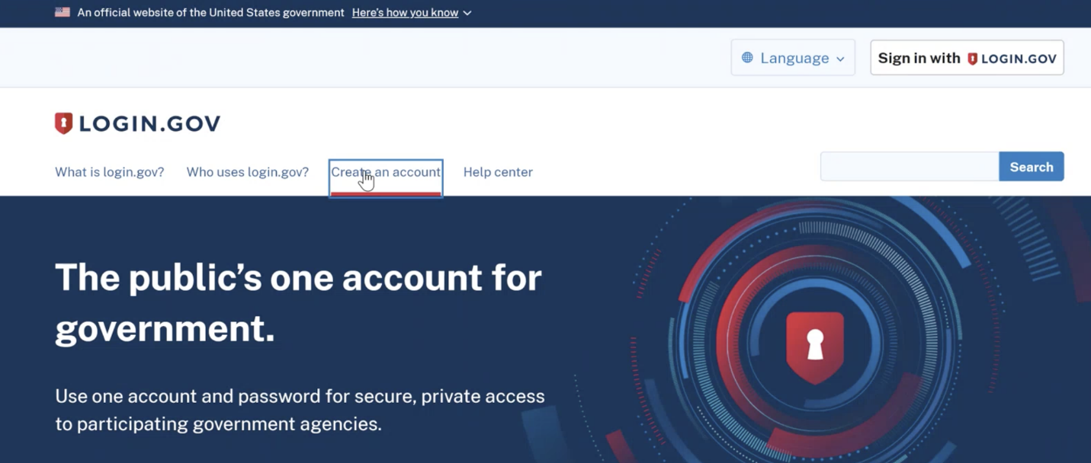
- After signing in, the system will redirect you to your SAM.gov workspace.
- From your Workspace select the “Register Entity” button.
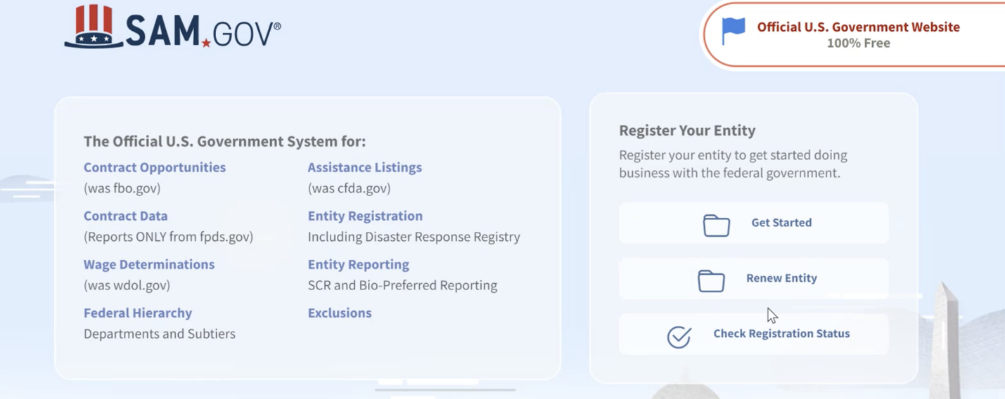
- Select the “Get Started” button of the registration overview page.
- Review the Before You Start information, and gather the required information needed to complete your registration:
  - You will need a Unique Entity identifier (UEI) from Dun and Bradstreet, referred to here as a DUNS number
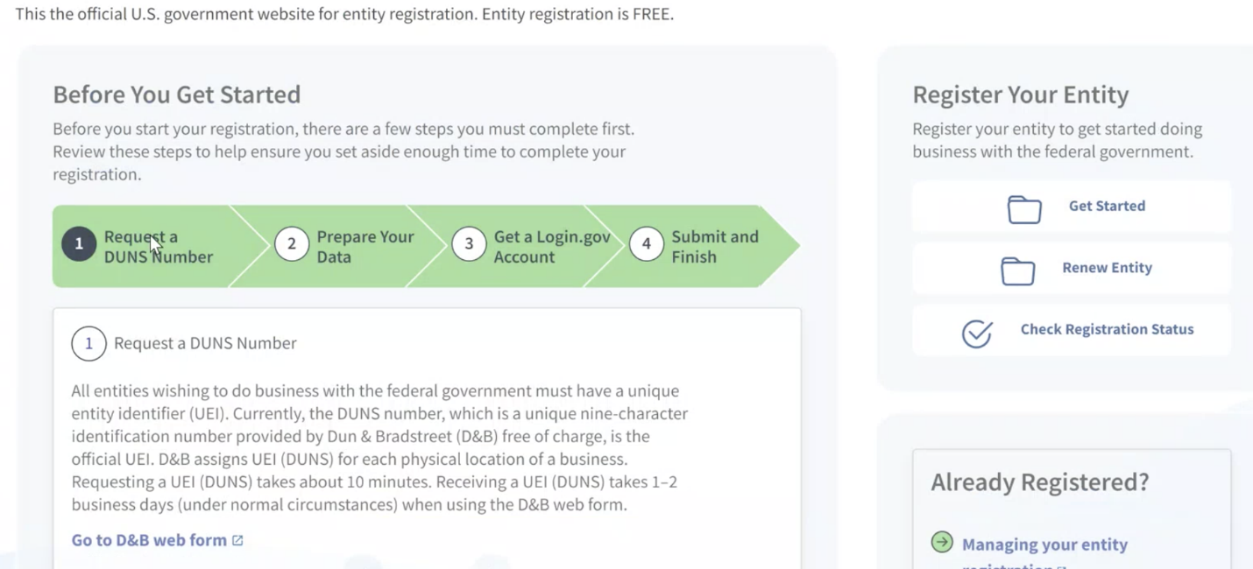
  - Entity Information
    - legal business name
    - physical address
    - entity type
    - general entity information
  - NATO Commercial and Government Entity (NCAGE) code if your entity is located outside of the U.S. and its territories
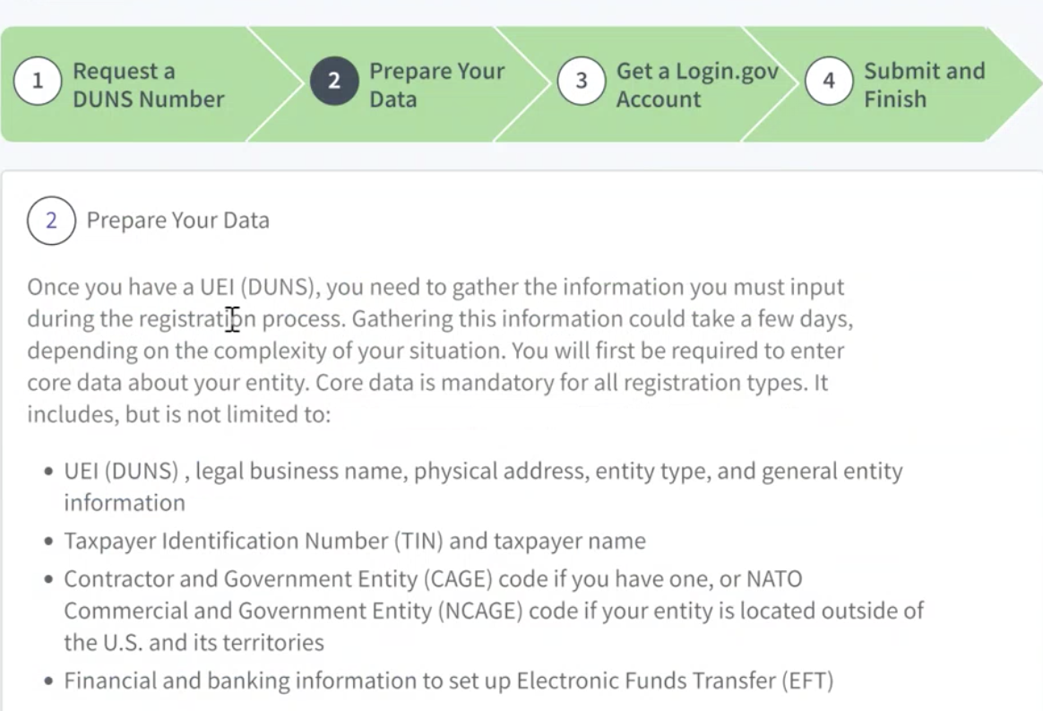
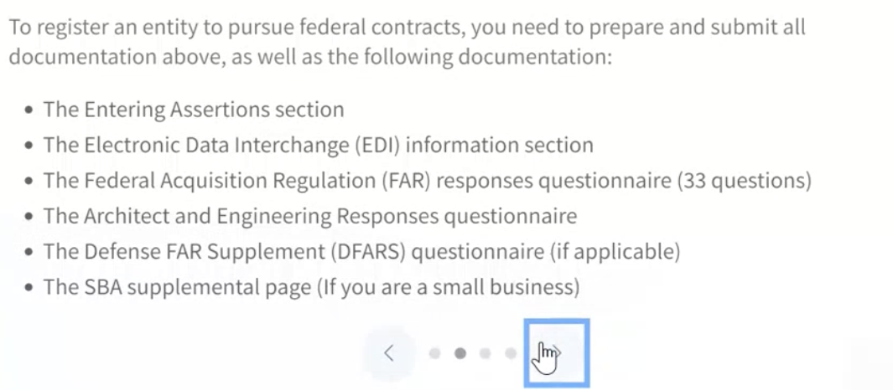
- Select the “Continue” button to proceed.
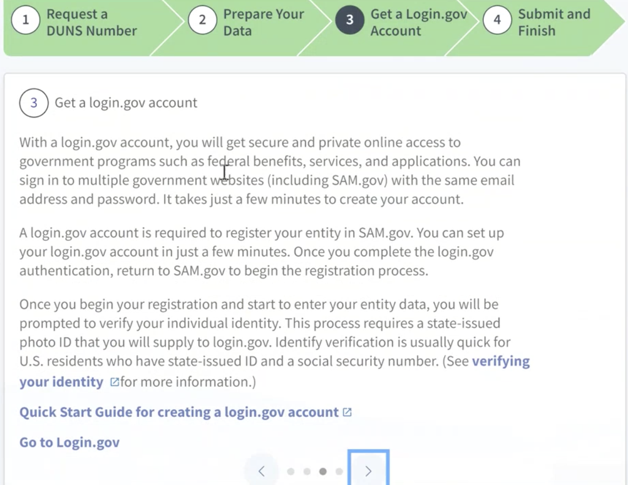
- Complete and submit the online registration. If you have all the necessary information this should take approximately 45 minutes to complete. The time to complete could vary depending on the size and complexity of your registration.
Please allow up to 10 business days after submitting your registration for it to become active in SAM. The processing time may be longer if either party flags the registration data for manual validation.
If you notice your registration has a status of Submitted for 15 business days or longer, and have not otherwise been contacted by the IRS or DLA to correct or update the necessary information, please contact the Federal Service Desk.

- Update an Existing Entity in SAM
Note: If your SAM.gov Entity Administrator is no longer with the company or there is not an Entity Administrator associated with the registration, please create a user account and submit a Notarized Letter to gain access to the existing registration.
To update your entity's SAM registration, follow the steps below:
- Navigate to SAM.gov.
- Select the “Sign In” button in the upper right corner. Select “Accept” to accept the US Government System terms.
- After selecting “Accept,” the system will direct you to login.gov.
  - Enter your login.gov credentials and select “Sign In.” You may be prompted to enter a one-time security code. (You will receive this code via the authentication method you selected during account creation.) Note: If you do not already have a login.gov account, please create an account.
- After signing in, the system will redirect you to your SAM.gov workspace.
- In the workspace, find the Entity Registration widget.
- Select the icon above “Active” to display a list of your active registrations. Note: If you do not have an existing Entity registration, you will need to complete a new registration. If you are unable to access an existing Entity registration (active or inactive), you will need to request an SAM.gov Entity Registration role.
- Locate the entity record you want to update, select the ellipsis in the top-right corner near the expiration date, and select “Update.”
- Review, and if needed, update the following information:
  - Update the Core Data section.
  - Update the Assertions section
    - Not required if registering for Federal Assistance opportunities only.
  - Update the Representations and Certifications section.
- Update the Points of Contact (POCs) section, including optional POCs.
  - You may remove optional POCs if they are no longer relevant.
- If you qualify as a small business, update your information in the Small Business Administration’s (SBA) Dynamic Small Business Search (DSBS) or apply for a small business certification via the SBA Supplemental page.
- Select “Submit.”
- Review then confirm your submission.
Once you have submitted the update, you cannot make changes until the submitted registration is processed, or if a validation step has failed.
The processing time may be longer if either party flags the registration data for manual validation.
You will receive a confirmation email once the registration is active. At that time, you will be eligible to apply for Federal Contracts and Financial Assistance from the U.S. Federal Government. Please allow an additional 24 hours before your active registration information is available in other government systems.

